DIRECTIONS TO ENCHANTED FOREST

Take Redwood Highway (Hwy 199) West to Riverbanks Road. This turn is near the 7 mile marker and just over the Applegate Bridge. Go north on Riverbanks (turn left from Cave Junction or right from Grants Pass). Follow Riverbanks approximately 6 miles to Shan Creek Road. Go up Shan Creek Road 9/10 of a mile to the driveway with a bank of mailboxes on the left. The end mailbox looks like a VW Bus. (Our actual number is 369 but we are past the driveway with the other 300’s and up to where the 800 and 1000’s are)
Turn left on that driveway and go about ½ mile to the fork in the road (where there is a camp sign) Take the left fork and the parking area will be directly to the right. Someone will meet you in the parking lot if you arrive at the starting time. Otherwise follow the signs to the skylodge.
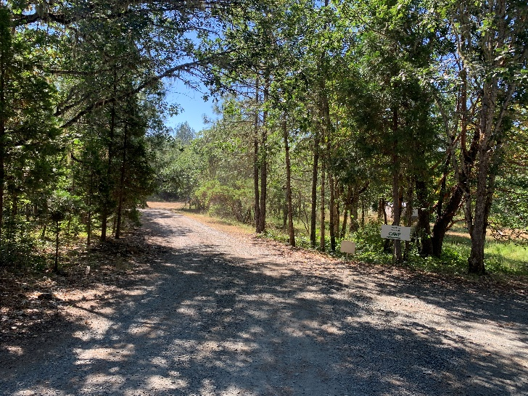
We respectfully request that you keep your speed to 12 mph while driving on the ½ mile driveway to Enchanted Forest. It is an easement that we share with our neighbors and we wish to keep the dust down and our children and animals safe. Thank you for your cooperation.

If you get lost, please call 541 476-0397

